PLANNING AND SCAFFOLDING THE APP

i. Why this matters
Christopher Bienko (AI Enablement GTM Product Manager) provides an overview of the Planning and Scaffolding the Application module for the hands-on enablement. [2 min]
Before generating a single line of code, IBM Bob should understand what it is being asked to build. Scaffolding an application without that context tends to produce boilerplate that has to be thrown away — plausible React code that does not match the repository, the workshop goals, or the delivery workflow.
Modern GitHub-driven engineering follows the opposite pattern. A clear plan is drafted first. Component boundaries, service layers, state management, and validation strategy are agreed up front. Only then does implementation begin, and every file that lands in the repository maps to a decision that was made deliberately.
The application will track IBM and four major competitors — Microsoft, Oracle, SAP, and Salesforce — using Yahoo Finance data across three time windows: current day, last 7 days, and last quarter.
In this module, you will use IBM Bob to inspect the workshop starter repository, produce a structured implementation plan for a React finance dashboard, and then scaffold the application in a shape that supports later GitHub-driven feature evolution.
Pay attention to how Bob frames the greenfield task as an engineering exercise— folder layout, data-service boundaries, error handling, test strategy —rather than a code-generation shortcut.

ii. Planning and scaffolding the application
ATTENTION: NON-DETERMINISTIC WORK AHEAD
Bob's responses are non-deterministic, so the plan and file layout produced in your IDE may differ from those shown here. It's also possible that some architectural choices — folder names, chart library, state management approach — will vary from run to run.
IBM Bob is powered by generative AI and LLMs, and a defining trait of these systems is that they are non-deterministic — unlike the deterministic tools most developers are accustomed to. In practice, that means the same prompt can produce different code from one run to the next. This is both a strength and a quirk of the technology, and it is something to work with rather than against.
All this is to say: Your results ahead may vary. The key takeaway from these workflows is that you understand how to effectively utilize each of Bob's Modes and where their strengths are best applied. Whether or not you arrive at the exact same codebase at the end is of less importance. Bob will ensure either way that your application works and delivers more-or-less what you asked for. The exact implementation and steps that Bob takes to arrive at that result, however, may differ from the steps documented here.
The starter repository contains only the workshop scaffolding: documentation, a pull request template, and a CI workflow. Everything else, including the React project itself, will be generated by Bob.
You will move through this module in two phases. First to ask Bob to analyze the repository and propose an implementation plan. Then to approve the plan and let Bob scaffold the application sub-task by sub-task. By the end of the module, the app will run locally in mock mode and render its first dashboard view.

- Open the workshop repository inside the Bob IDE.
  - Click the Explorer tab along the left edge of the IDE.
  - If no folder is currently open, click the Open Folder button to expose the file picker.
  - Navigate to the GitHub SDLC Automation folder from the Setup module, select it, and click Open.
  - Bob will load the workspace, index the repository, and prepare the Agentic Sidebar.
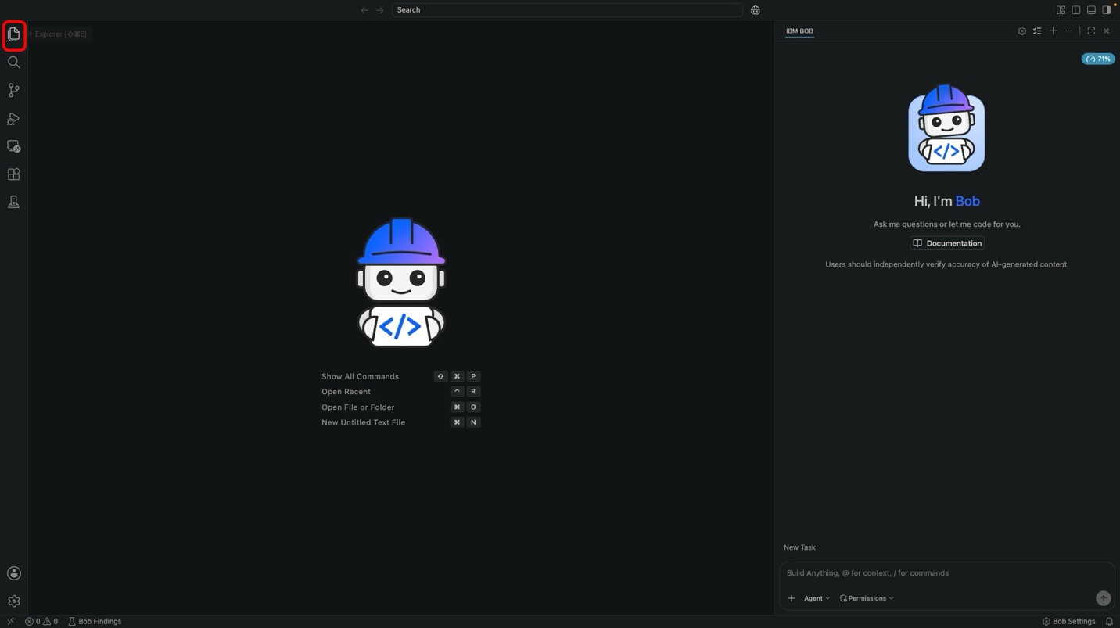
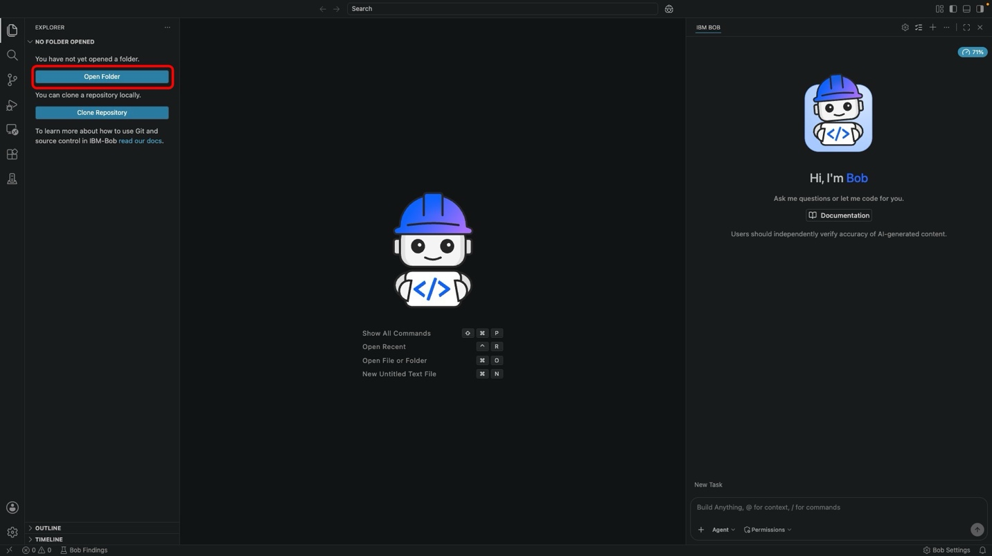
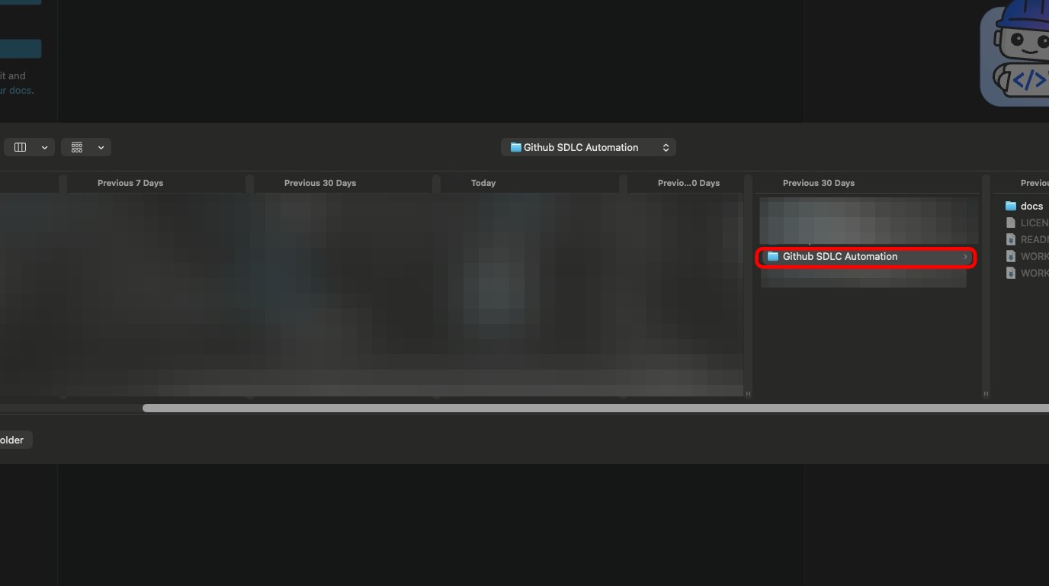

- With Agent mode active, copy and paste the following task into the Agentic Sidebar session window. This is the analysis and planning prompt for the entire finance dashboard.
Analyze this repository as the starting point for a new React-based finance analytics lab. Propose an implementation plan for a market dashboard application that tracks IBM and up to four competitors using Yahoo Finance data. The application should present three time-window views: current day, last 7 days, and last quarter. Recommend a practical architecture including source folders, React component boundaries, data service abstractions, charting approach, state management strategy, error handling, test strategy, and local validation steps. Also explain how the implementation should support later GitHub-driven feature evolution through issues and pull requests.
With the prompt entered, hit Enter or press the Send button to the right of the chat interface.
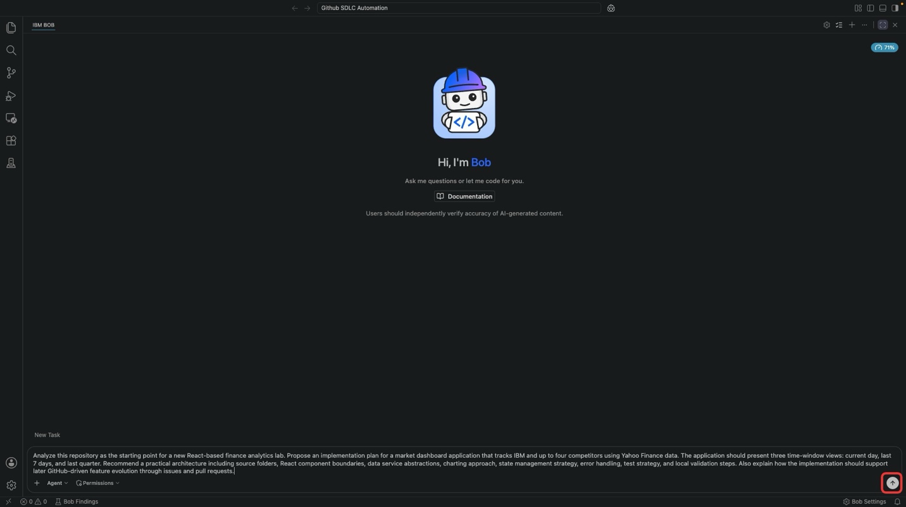

- Bob will explore the repository, then produce a rich HTML implementation plan. The Agentic Sidebar will summarize the key architecture decisions: source layout, component boundaries, data service, charting, state management, error handling, test strategy, and GitHub evolution model.
  - Click Open on the Market Dashboard — Implementation Plan report to review the full plan in the IDE.
  - The generated plan opens directly inside the Bob IDE as a self-contained HTML report. It covers the application overview, source folder layout, component boundaries, data-service architecture, and the GitHub evolution model that Part 2 | Evolve will build on.
  - Scroll through the report and confirm that the plan matches the workshop goal before moving on. This is the last checkpoint before Bob starts writing code.
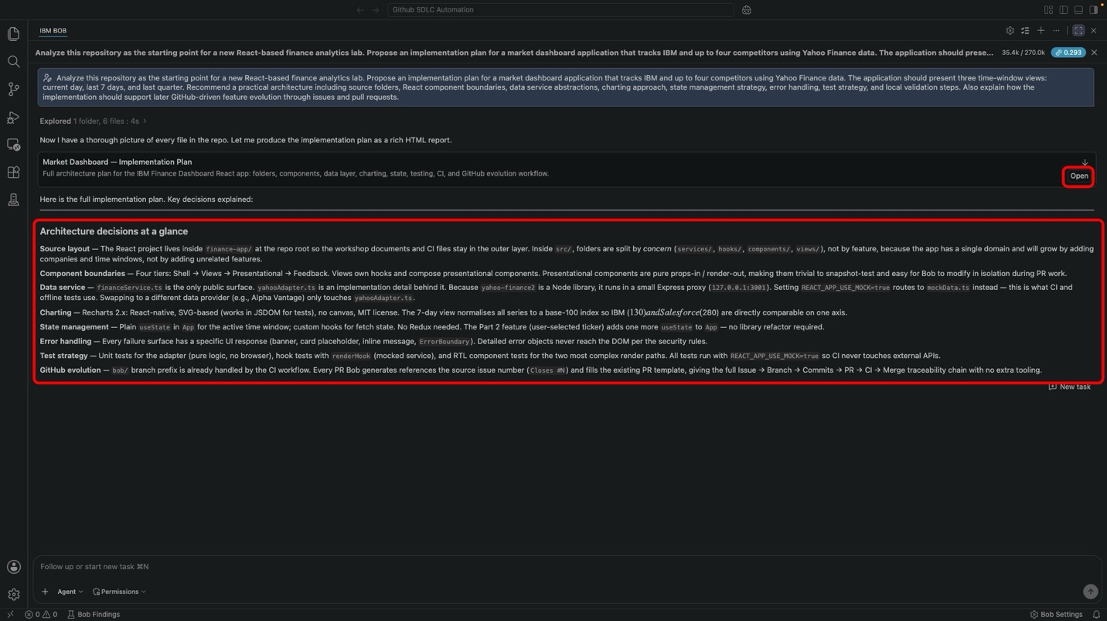
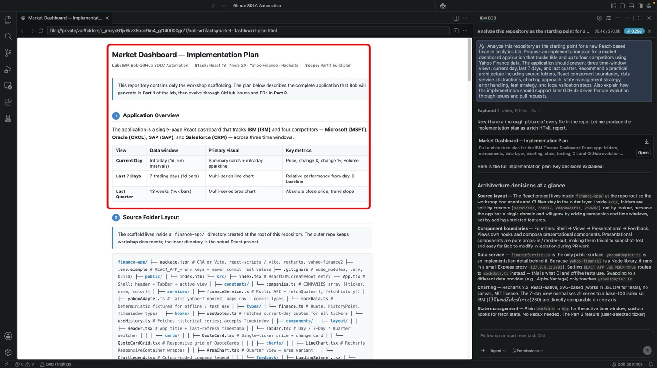

- With the plan reviewed, ask Bob to scaffold the application. Copy and paste the following prompt into the Agentic Sidebar:
- Create a simple React application structure for this repository. Include a dashboard page, reusable chart card components, a finance data service layer, and a clean folder layout suitable for future enhancements.
Press Enter to submit the task for execution within the Agentic Sidebar.
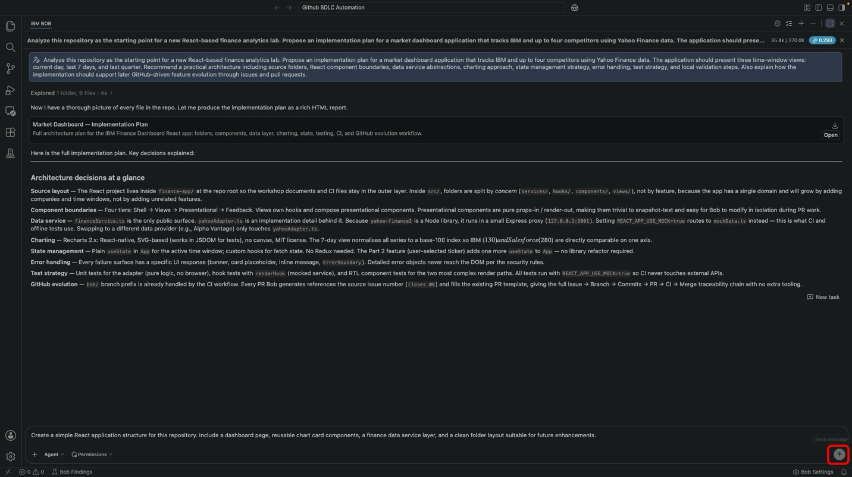

- After submitting your scaffolding request, Bob will first re-read the implementation plan and generate a detailed execution roadmap presented as a Todo List.
  - Review the proposed plan carefully to ensure it aligns with the folder layout, component boundaries, and validation strategy from the plan
  - Once the plan has been reviewed, click Approve todo tools for task
Bob will begin executing the scaffolding workflow. During implementation, Bob may request approval before performing certain actions such as creating files, modifying source code, running build commands, executing tests, or installing dependencies. Review these requests and approve them as needed.
Bob will generate an Update Todo List with the following (or similar) sub-tasks:
TASK | OBJECTIVES
Sub-Task 1 | Scaffold React app with Vite + TypeScript
Sub-Task 2 | Create constants, types, and mock data
Sub-Task 3 | Implement data service layer
Sub-Task 4 | Implement custom hooks
Sub-Task 5 | Build layout components
Sub-Task 6 | Build feedback components
Sub-Task 7 | Build card components
Sub-Task 8 | Build chart components
Sub-Task 9 | Build view components
Sub-Task 10 | Wire up App shell, tests, and configuration
Sub-Task 11 | Run local validation (lint + test + build)
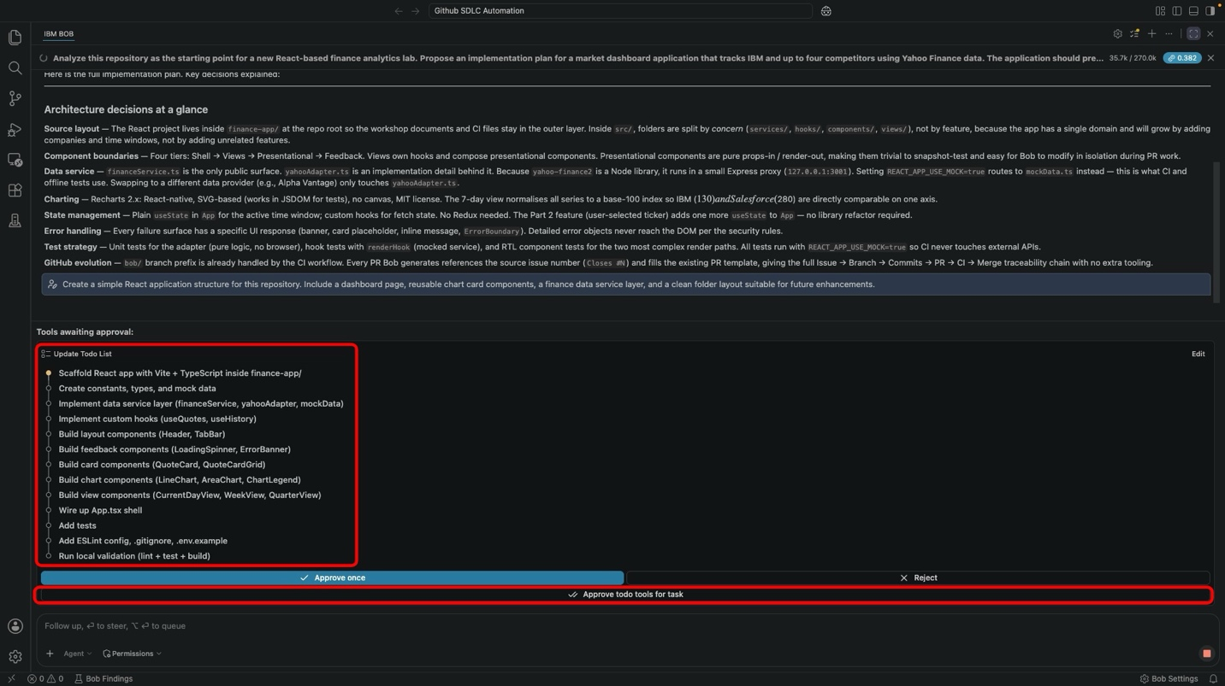

SEQUENCING THE SUB-TASKS
In the steps ahead, you will examine in detail what each Sub-Task is performing and understand the rationale for the change. With your approval, Bob will then go ahead and implement the work on your behalf.

Sub-Task 1: Scaffold React App with Vite + TypeScript
Before writing any application code, Bob initializes a new React 18 project using Vite as the build tool and TypeScript for type safety. This establishes the base package.json, tsconfig.json, index.html, and entry point files that every other sub-task will build on.
- Within the Agentic Sidebar, you will be prompted with the following: Ready to implement Sub-Task 1. Shall I go ahead?
If you agree with the changes, type Yes and Enter to approve Sub-Task 1 execution.

- Continue approving any additional requests related to Sub-Task 1 until the Agentic Sidebar chat has reported back with a summary of Sub-Task 1 is done. Here's what has changed.
  - Project Initialization: Created a Vite + React 18 + TypeScript project inside finance-app/ with base package.json, tsconfig.json, index.html, and src/main.tsx entry point.
  - Base Configuration: Established the build toolchain, dev server configuration, and TypeScript strict mode settings for the project.

Sub-Task 2: Create Constants, Types, and Mock Data
Bob establishes the domain foundation for the application. This includes the COMPANIES registry (the single source of truth for tracked tickers), TypeScript types for Quote, HistoryPoint, and TimeWindow, and deterministic mock fixtures that let the app run offline during tests and development.
- Within the Agentic Sidebar, you will be prompted with the following: Ready to implement Sub-Task 2. Shall I go ahead?
If you agree with the changes, type Yes and Enter to approve Sub-Task 2 execution.

- Continue approving any additional requests related to Sub-Task 2 until the Agentic Sidebar chat has reported back with a summary of Sub-Task 2 is done. Here's what has changed.
  - Company Registry: Created constants/companies.ts with the five tracked tickers (IBM, MSFT, ORCL, SAP, CRM) as the single source of truth.
  - Domain Types: Established types/finance.ts with Quote, HistoryPoint, and TimeWindow types used across the service, hook, and view layers.
  - Mock Fixtures: Created deterministic seeded mock data so the app can run and be tested without external network access.

Sub-Task 3: Implement Data Service Layer
Bob creates the data-access layer with a clean separation of concerns: financeService.ts exposes the public API, yahooAdapter.ts maps raw Yahoo Finance responses to domain types, and mockData.ts supplies deterministic fixtures. This isolation keeps the UI independent of the data source and makes swapping providers a one-file change.
- Within the Agentic Sidebar, you will be prompted with the following: Ready to implement Sub-Task 3. Shall I go ahead?
If you agree with the changes, type Yes and Enter to approve Sub-Task 3 execution.

- Continue approving any additional requests related to Sub-Task 3 until the Agentic Sidebar chat has reported back with a summary of Sub-Task 3 is done. Here's what has changed.
  - Public Service Interface: Created services/financeService.ts as the sole entry point for quote and history fetching.
  - Yahoo Adapter: Implemented services/yahooAdapter.ts to map raw API responses into the domain model, with null-safe handling for missing optional fields.
  - Mock/Live Seam: Wired the service to switch between live and mock data based on the VITE_USE_MOCK environment variable.

Sub-Task 4: Implement Custom Hooks
Bob creates two custom React hooks that encapsulate all data-fetching state: useQuotes returns current-day quotes for all tracked tickers with loading and error states, and useHistory returns historical time-series data for a given TimeWindow. Views remain pure props-in / render-out, which makes them trivial to test.
- Within the Agentic Sidebar, you will be prompted with the following: Ready to implement Sub-Task 4. Shall I go ahead?
If you agree with the changes, type Yes and Enter to approve Sub-Task 4 execution.

- Continue approving any additional requests related to Sub-Task 4 until the Agentic Sidebar chat has reported back with a summary of Sub-Task 4 is done. Here's what has changed.
  - useQuotes Hook: Created hooks/useQuotes.ts to fetch current-day quotes for all tracked tickers with idle, loading, error, and success states.
  - useHistory Hook: Created hooks/useHistory.ts to fetch historical time series scoped by TimeWindow ('7d' or 'quarter').

Sub-Task 5: Build Layout Components
Bob builds the shell components that frame the application. Header provides the IBM-blue banner with the app title and a refresh action, and TabBar provides the Day / 7 Days / Quarter navigation.
- Within the Agentic Sidebar, you will be prompted with the following: Ready to implement Sub-Task 5. Shall I go ahead?
If you agree with the changes, type Yes and Enter to approve Sub-Task 5 execution.

- Continue approving any additional requests related to Sub-Task 5 until the Agentic Sidebar chat has reported back with a summary of Sub-Task 5 is done. Here's what has changed.
  - Header Component: Created components/layout/Header.tsx with IBM-blue styling, application title, last-refresh timestamp, and refresh action.
  - TabBar Component: Created components/layout/TabBar.tsx with the three time-window tabs and active-state styling.

Sub-Task 6: Build Feedback Components
Bob builds the reusable feedback surfaces that every view will rely on: LoadingSpinner for pending states (with an ARIA role for accessibility) and ErrorBanner for failed fetches (with a retry action).
- Within the Agentic Sidebar, you will be prompted with the following: Ready to implement Sub-Task 6. Shall I go ahead?
If you agree with the changes, type Yes and Enter to approve Sub-Task 6 execution.

- Continue approving any additional requests related to Sub-Task 6 until the Agentic Sidebar chat has reported back with a summary of Sub-Task 6 is done. Here's what has changed.
  - LoadingSpinner Component: Created components/feedback/LoadingSpinner.tsx with animated indicator and accessible ARIA role.
  - ErrorBanner Component: Created components/feedback/ErrorBanner.tsx with warning styling and a retry callback.

Sub-Task 7: Build Card Components
Bob builds the reusable card primitives — QuoteCard renders a single ticker's price and change, and QuoteCardGrid arranges the cards in a responsive grid that adapts across screen sizes.
- Within the Agentic Sidebar, you will be prompted with the following: Ready to implement Sub-Task 7. Shall I go ahead?
If you agree with the changes, type Yes and Enter to approve Sub-Task 7 execution.

- Continue approving any additional requests related to Sub-Task 7 until the Agentic Sidebar chat has reported back with a summary of Sub-Task 7 is done. Here's what has changed.
  - QuoteCard Component: Created components/cards/QuoteCard.tsx displaying ticker, price, change amount, change percentage, and volume with color-coded gain/loss styling.
  - QuoteCardGrid Component: Created components/cards/QuoteCardGrid.tsx as a responsive grid wrapper for the current-day view.

Sub-Task 8: Build Chart Components
Bob builds the visualization components using Recharts. LineChart renders the 7-day trend with all tickers rebased to an index of 100 for direct comparison. AreaChart renders the 13-week quarterly trend. ChartLegend provides a color-coded company legend shared across both charts.
- Within the Agentic Sidebar, you will be prompted with the following: Ready to implement Sub-Task 8. Shall I go ahead?
If you agree with the changes, type Yes and Enter to approve Sub-Task 8 execution.

- Continue approving any additional requests related to Sub-Task 8 until the Agentic Sidebar chat has reported back with a summary of Sub-Task 8 is done. Here's what has changed.
  - LineChart Component: Created components/charts/LineChart.tsx with a Recharts responsive container and normalization to a base-100 index.
  - AreaChart Component: Created components/charts/AreaChart.tsx for the quarterly view with a stacked area presentation.
  - ChartLegend Component: Created components/charts/ChartLegend.tsx with a color-coded strip identifying each tracked company.

Sub-Task 9: Build View Components
Bob assembles the three time-window views. Each view is a thin composition of the hooks and components already built: CurrentDayView renders QuoteCardGrid via useQuotes, WeekView renders LineChart via useHistory('7d'), and QuarterView renders AreaChart via useHistory('quarter').
- Within the Agentic Sidebar, you will be prompted with the following: Ready to implement Sub-Task 9. Shall I go ahead?
If you agree with the changes, type Yes and Enter to approve Sub-Task 9 execution.

- Continue approving any additional requests related to Sub-Task 9 until the Agentic Sidebar chat has reported back with a summary of Sub-Task 9 is done. Here's what has changed.
  - CurrentDayView: Created views/CurrentDayView.tsx composing quote cards via useQuotes with loading and error surfaces.
  - WeekView: Created views/WeekView.tsx rendering the rebased line chart via useHistory('7d').
  - QuarterView: Created views/QuarterView.tsx rendering the quarterly area chart via useHistory('quarter').

Sub-Task 10: Wire Up App Shell, Tests, and Configuration
Bob wires everything together in App.tsx — the shell composes the Header, TabBar, active view, and an ErrorBoundary. Bob then adds unit tests for the data adapter, mock fixtures, and one card component, plus configuration files (ESLint, .gitignore, .env.example) that the CI workflow depends on.
- Within the Agentic Sidebar, you will be prompted with the following: Ready to implement Sub-Task 10. Shall I go ahead?
If you agree with the changes, type Yes and Enter to approve Sub-Task 10 execution.

- Continue approving any additional requests related to Sub-Task 10 until the Agentic Sidebar chat has reported back with a summary of Sub-Task 10 is done. Here's what has changed.
  - App Shell: Created src/App.tsx with active-view state management, ErrorBoundary wrapper, and global styles.
  - Test Suite: Added unit tests for the yahoo adapter, mock data determinism, and a QuoteCard rendering path using Testing Library and jest-dom.
  - Configuration Files: Added ESLint config, .gitignore, and .env.example documenting the VITE_USE_MOCK environment variable.

Sub-Task 11: Run Local Validation
Bob runs a complete validation cycle — ESLint, the Jest test suite, and the TypeScript build — to confirm the scaffold compiles cleanly, every test passes, and no linting issues remain. This is the last gate before the app is considered scaffold-complete.
- Within the Agentic Sidebar, you will be prompted with the following: Ready to implement Sub-Task 11. Shall I go ahead?
If you agree with the changes, type Yes and Enter to approve Sub-Task 11 execution.

- Continue approving any additional requests related to Sub-Task 11 until the Agentic Sidebar chat has reported back with a summary of Sub-Task 11 is done. Here's what has changed.
  - Validation Gate: Executed npm run lint, npm test, and npm run build to compile the application and validate all generated code.
  - Scaffold Verification: Confirmed zero lint errors, all tests passing, and a clean TypeScript build — demonstrating that the scaffold is ready to run and to be extended in the next module.

- At this stage, all eleven sub-tasks have been completed and validated. Bob will present a full file inventory of the generated scaffold along with a Running the app locally block containing the commands you need next.
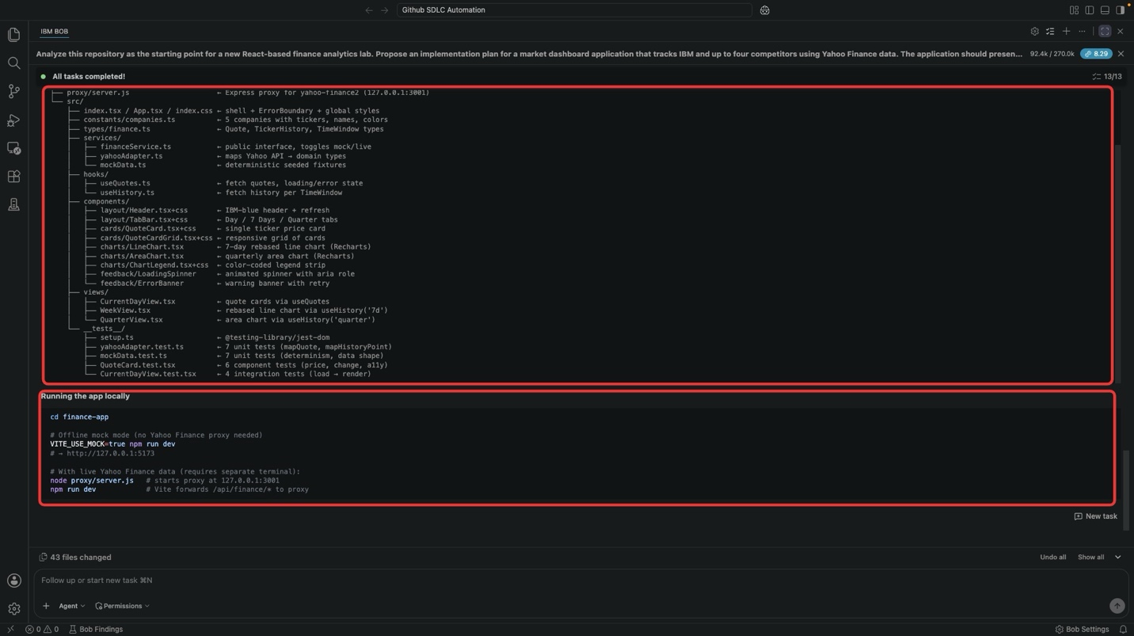

- To run the app, open a new Terminal window within the Bob IDE.
  - From the menu bar, select: Terminal → New Terminal (or press Ctrl+Shift+`)
  - A new console will appear at the bottom of the Bob IDE, awaiting input.
  - Copy the instructions below (taken from the Running the app locally block), paste them into the console, and press Enter to execute
- cd finance-app
- VITE_USE_MOCK=true npm run dev
Offline mock mode is the safest starting point — no Yahoo Finance proxy is required.
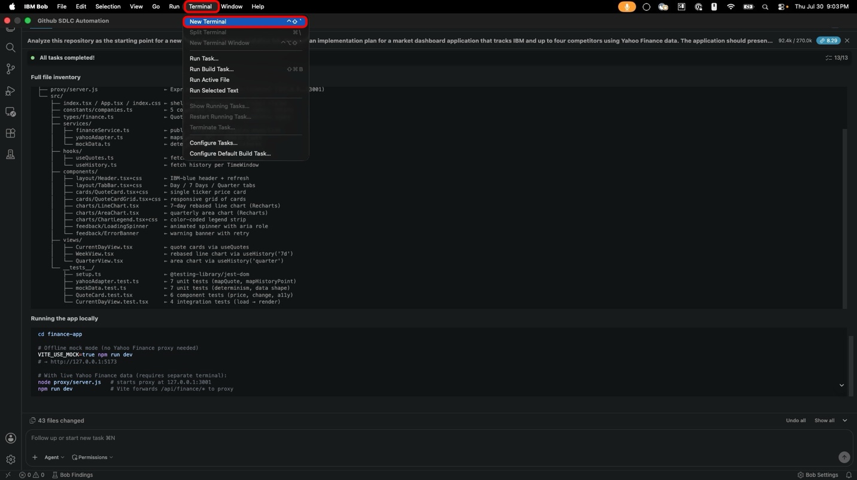
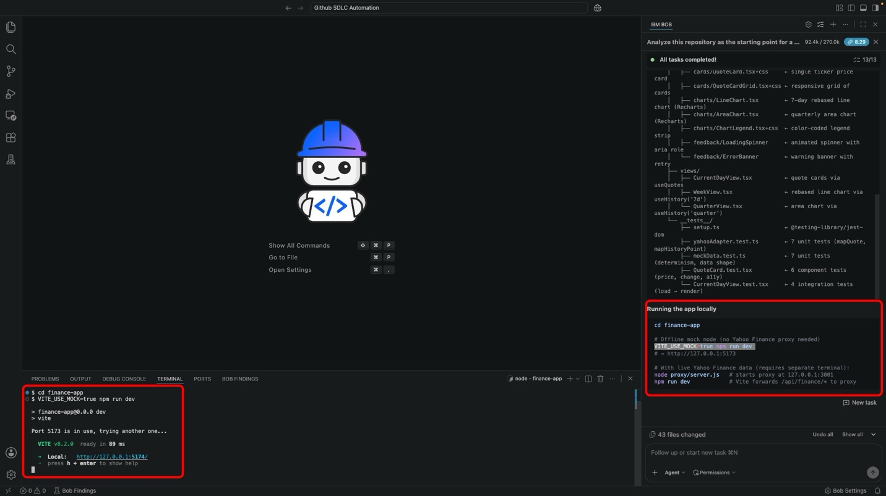

- Vite will start the dev server and print a local URL — typically http://127.0.0.1:5173/ (or the next free port).
  - Open the URL reported within the console output using your web browser
  - The Market Dashboard will load with the Current Day view selected by default, showing IBM alongside the four competitor tickers
  - The scaffolded shell is now running end-to-end. The Last 7 Days and Last Quarter tabs are wired but still empty — those remaining views are what the next steps will fill in
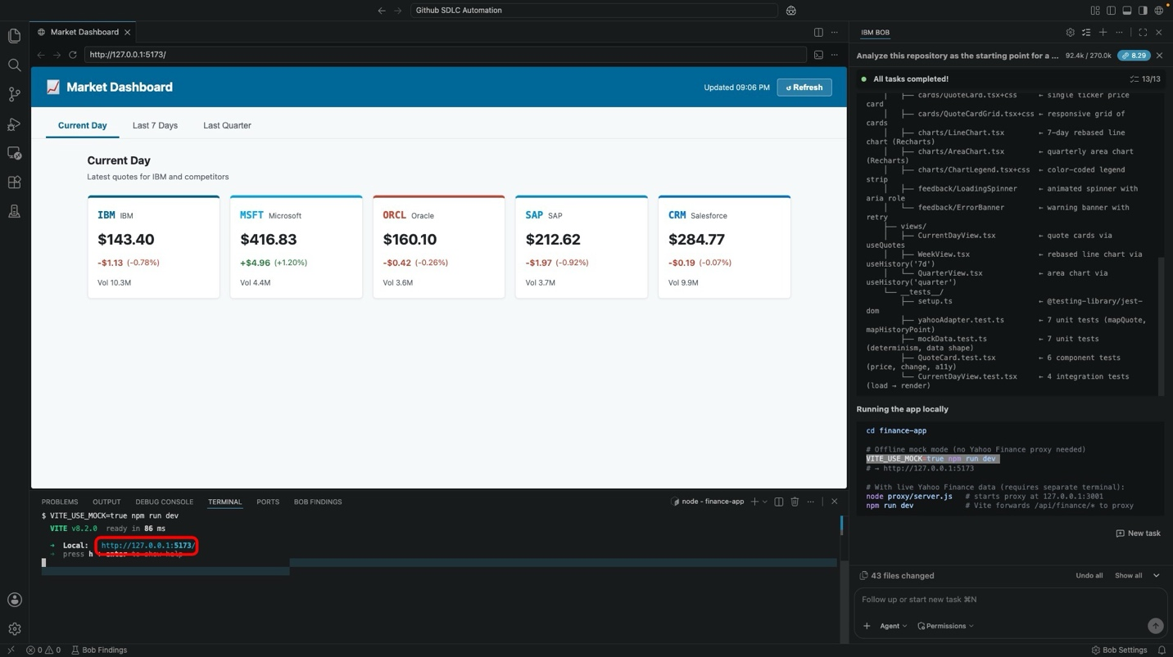

iii. Reviewing the generated scaffold
Before moving on, spend a few minutes exploring the generated project in the Explorer. Pay attention to:
- The finance-app/ folder layout — services, hooks, components, views
- The mock data seam (VITE_USE_MOCK) that lets the app run offline
- The company registry in constants/companies.ts (the single source of truth for tracked tickers)
- The empty view components that Part 1 | Build's remaining steps will fill in
- The test files already stubbed for the data layer and one rendering path
BEFORE YOU MOVE ON
You can continue to tinker with the scaffold if you wish — but be mindful that every prompt consumes tokens, and larger scaffolds tend to burn more than you'd expect. Your account's token budget will only reset monthly for IBMers, and trial accounts will expire once the budget is exhausted. Save exploration for after the core lab flow is complete.
Every file here traces back to a sub-task in the plan you just walked through. That traceability is what makes the codebase easy for Bob (and for you) to evolve in Part 2 | Evolve.

iv. Key takeaways
- Planning first, then scaffolding sub-task by sub-task, produces a codebase that matches intent (not just plausible boilerplate)
- IBM Bob can turn a natural-language brief into a structured implementation plan with clear component and service boundaries
- Sub-task sequencing makes the scope of each generation step explicit before code is written and gives the developer a clear approval gate at every stage
- A mock-data seam lets the app run and be validated offline before any external integration is added
- Local validation (lint + tests + build) belongs inside the scaffold plan as its own sub-task
- Developers remain responsible for reviewing the plan, approving each sub-task, and validating the generated output
The next module builds on the scaffold. In 1-2 | Building and Validating the Dashboards, you will use Bob to integrate Yahoo Finance data, populate the three dashboard views, add validation, and prepare a review-ready commit for GitHub delivery.

Previous
Setup and registration

Next
1.2 Building and validating the dashboards

Copyright © 2026
Made with Material for MkDocs

